CHAPTER 4: SOFTWARE DESIGN DESCRIPTION

4.1. Purpose

4.2. Architecture Overview

4.2.1. System Architecture

#### MVC model

Model–view–controller (MVC) is a software architectural pattern for implementing user interfaces on computers. It divides a given application into three interconnected parts. This is done to separate internal representations of information from the ways information is presented to, and accepted from, the user

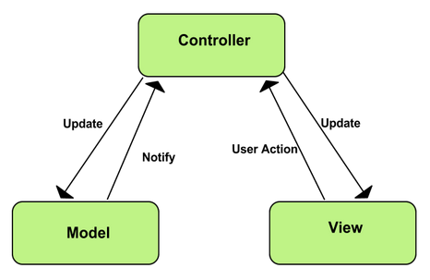

MVC Model

* **Model:** Model represents shape of the data and business logic. It maintains the data of the application. Model objects retrieve and store model state in a database.
* **View:** View is a user interface. View display data using model to the user and also enables them to modify the data.
* **Controller:** Controller handles the user request. Typically, user interact with View, which in-tern raises appropriate URL request, this request will be handled by a controller. The controller renders the appropriate view with the model data as a response.

#### Advantages and disadvantages of MVP model

* **Advantages**
  + **Faster development process:** MVC supports rapid and parallel development. With MVC, one programmer can work on the view while other can work on the controller to create business logic of the web application. The application developed using MVC can be three times faster than application developed using other development patterns.
  + **Ability to provide multiple views:** In the MVC Model, you can create multiple views for a model. Code duplication is very limited in MVC because it separates data and business logic from the display.
  + **Support for asynchronous technique:** MVC also supports asynchronous technique, which helps developers to develop an application that loads very fast.
  + **Modification does not affect the entire model:** Modification does not affect the entire model because model part does not depend on the views part. Therefore, any changes in the Model will not affect the entire architecture.
  + **MVC model returns the data without formatting:** MVC pattern returns data without applying any formatting so the same components can be used and called for use with any interface.
  + **SEO friendly Development platform**: Using this platform, it is very easy to develop SEO-friendly URLs to generate more visits from a specific application.
* **Disadvantages**
  + Increased complexity
  + Inefficiency of data access in view
  + Difficulty of using MVC with modern user interface.
  + Need multiple programmers
  + Knowledge on multiple technologies is required.
  + Developer have knowledge of client side code and html code.

4.3. Component Diagram

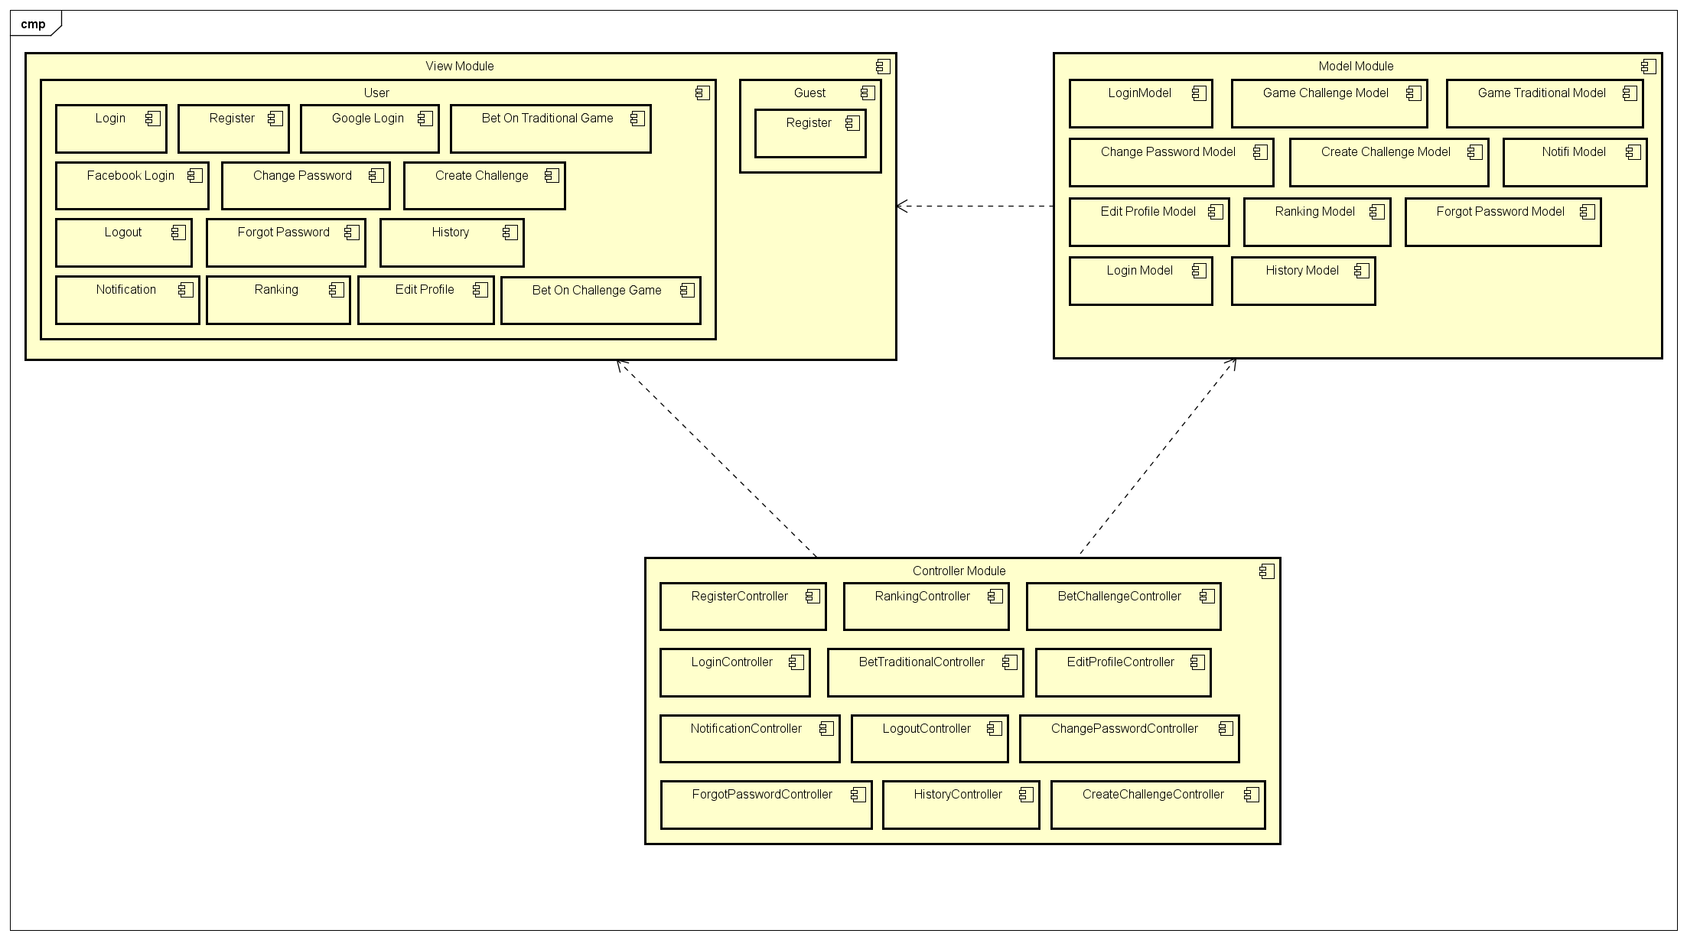

4.4. Sequence Diagram

Several sequence diagrams are shown in the following:

4.4.1. Register

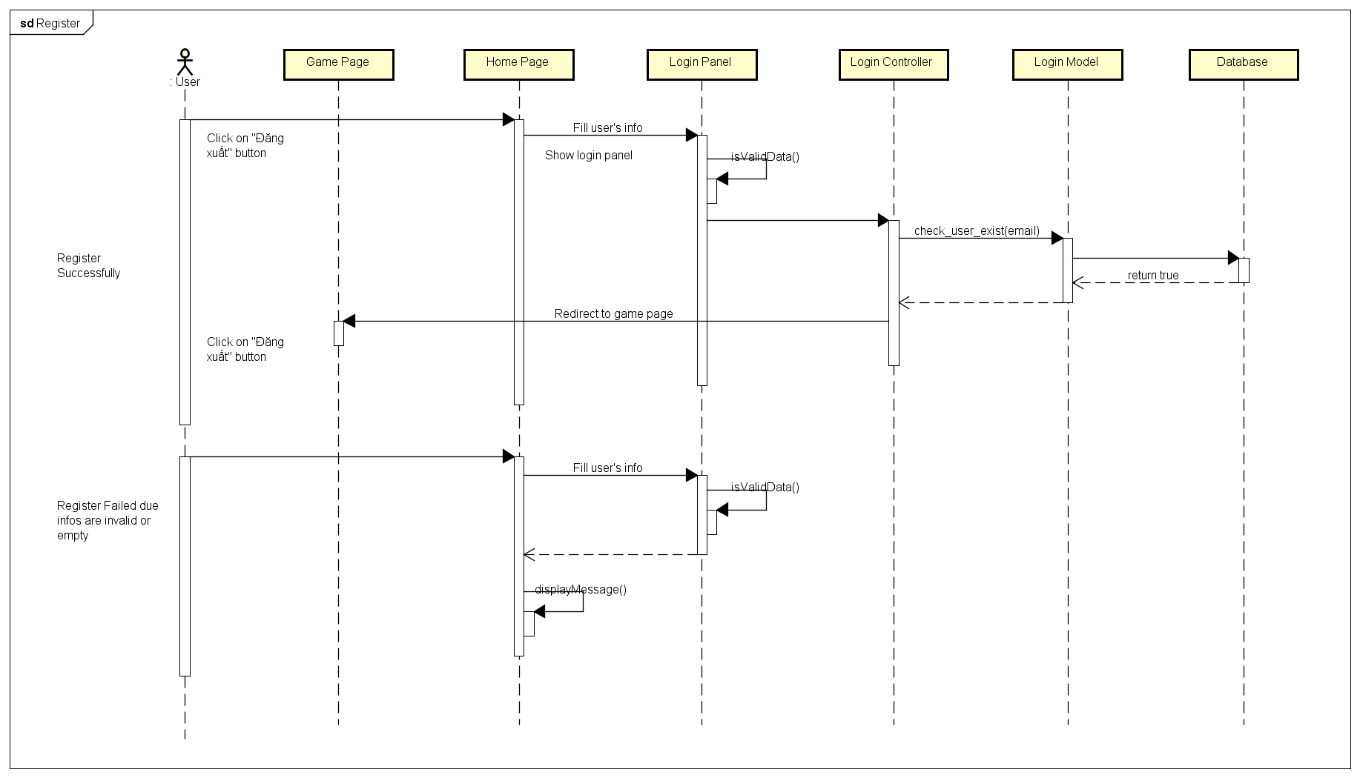

4.4.2. Login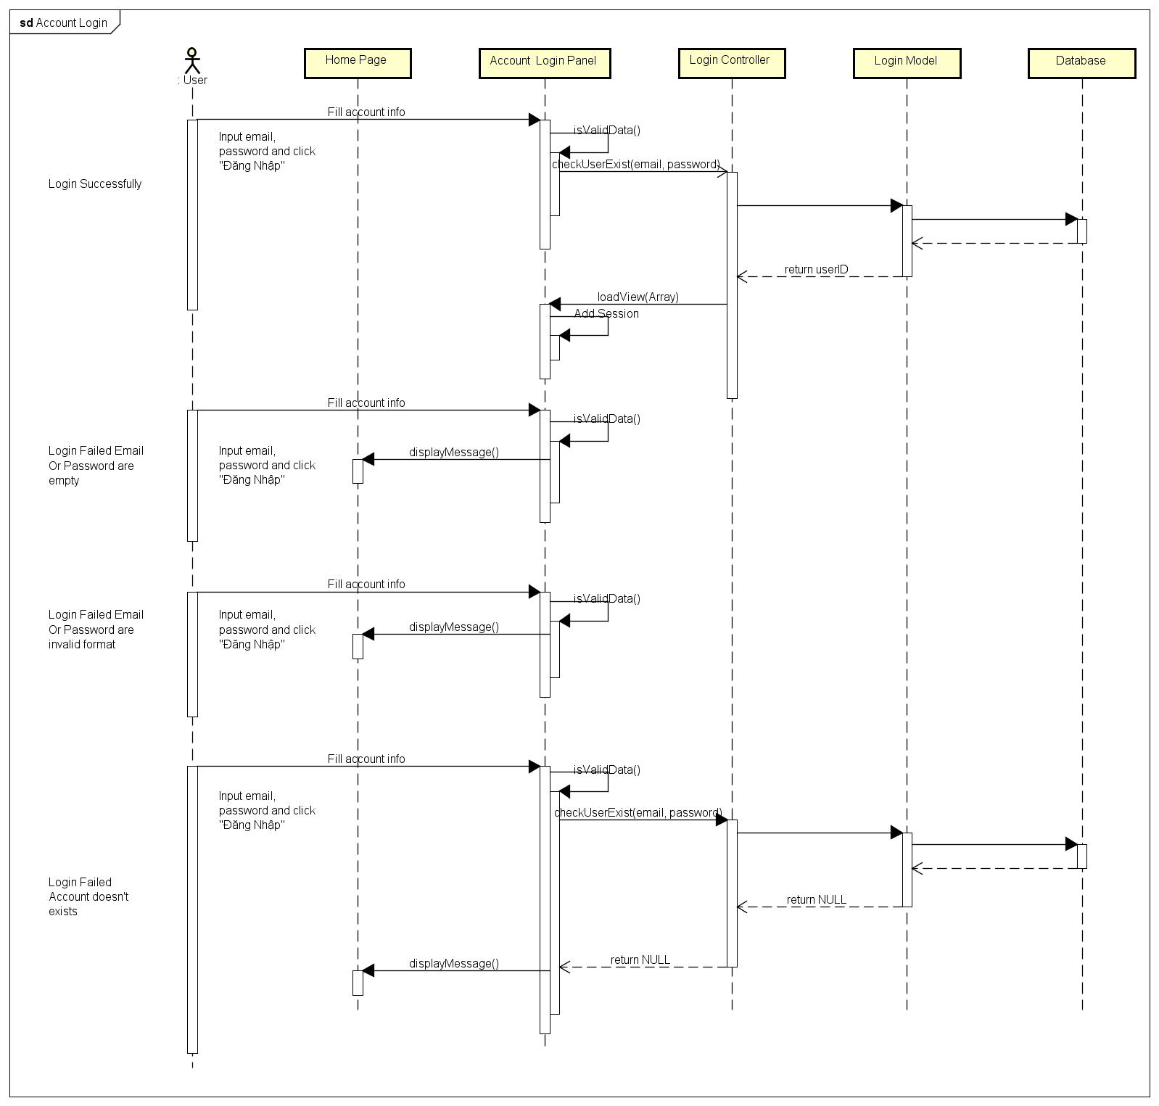

4.4.3. Login Using Facebook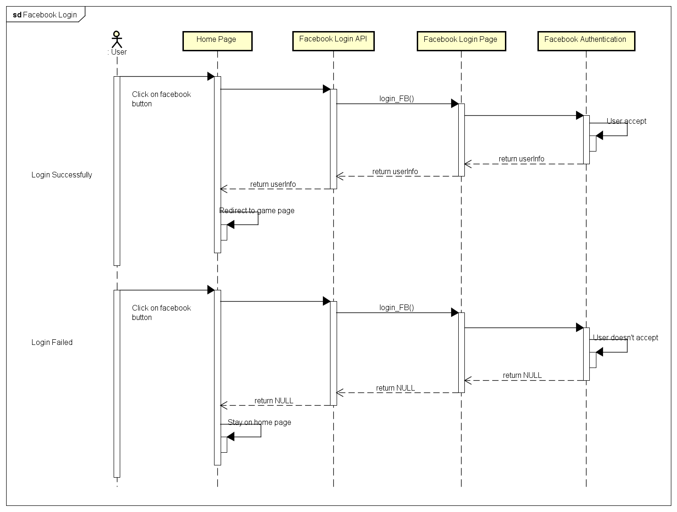

4.4.4. Login Using Google Plus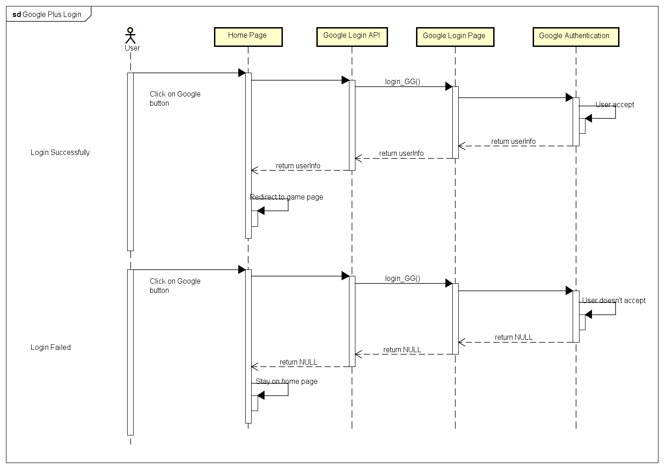

4.4.5. Logout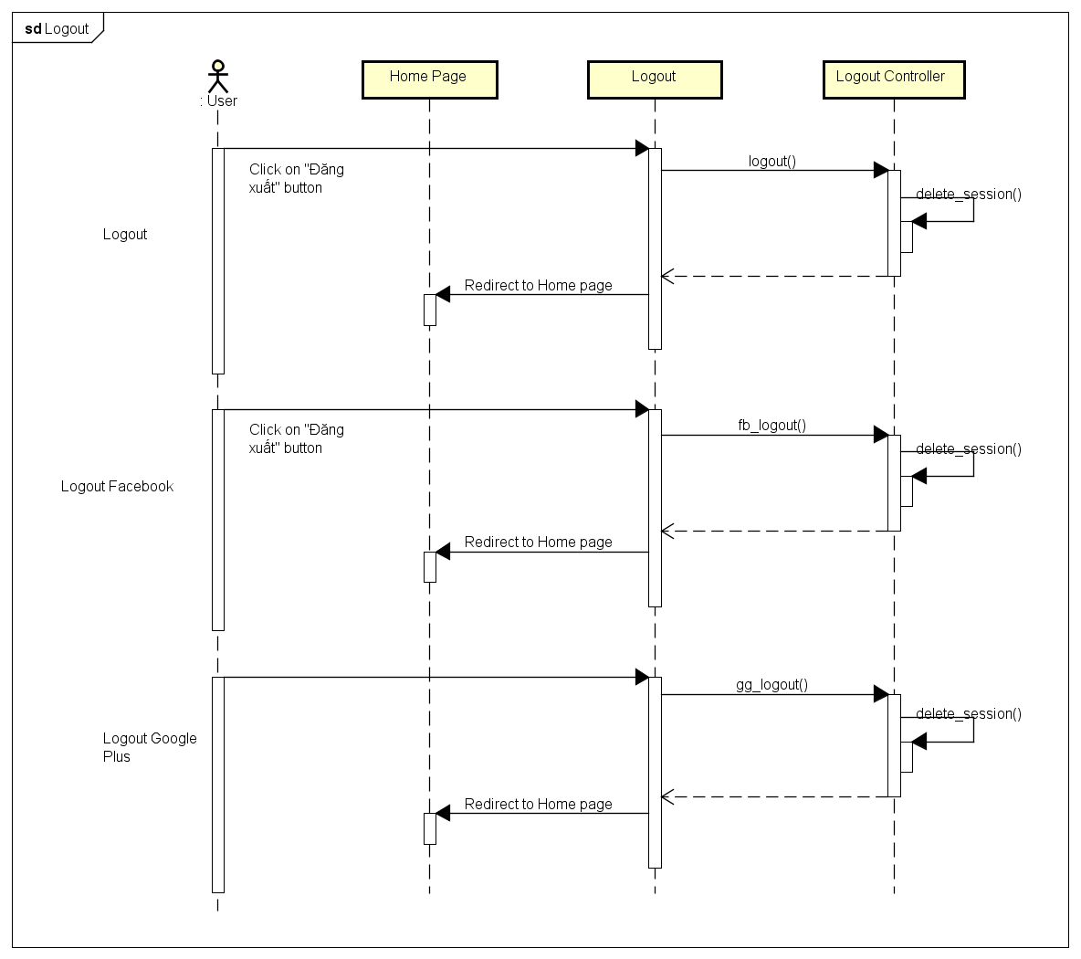

4.4.6. Change Password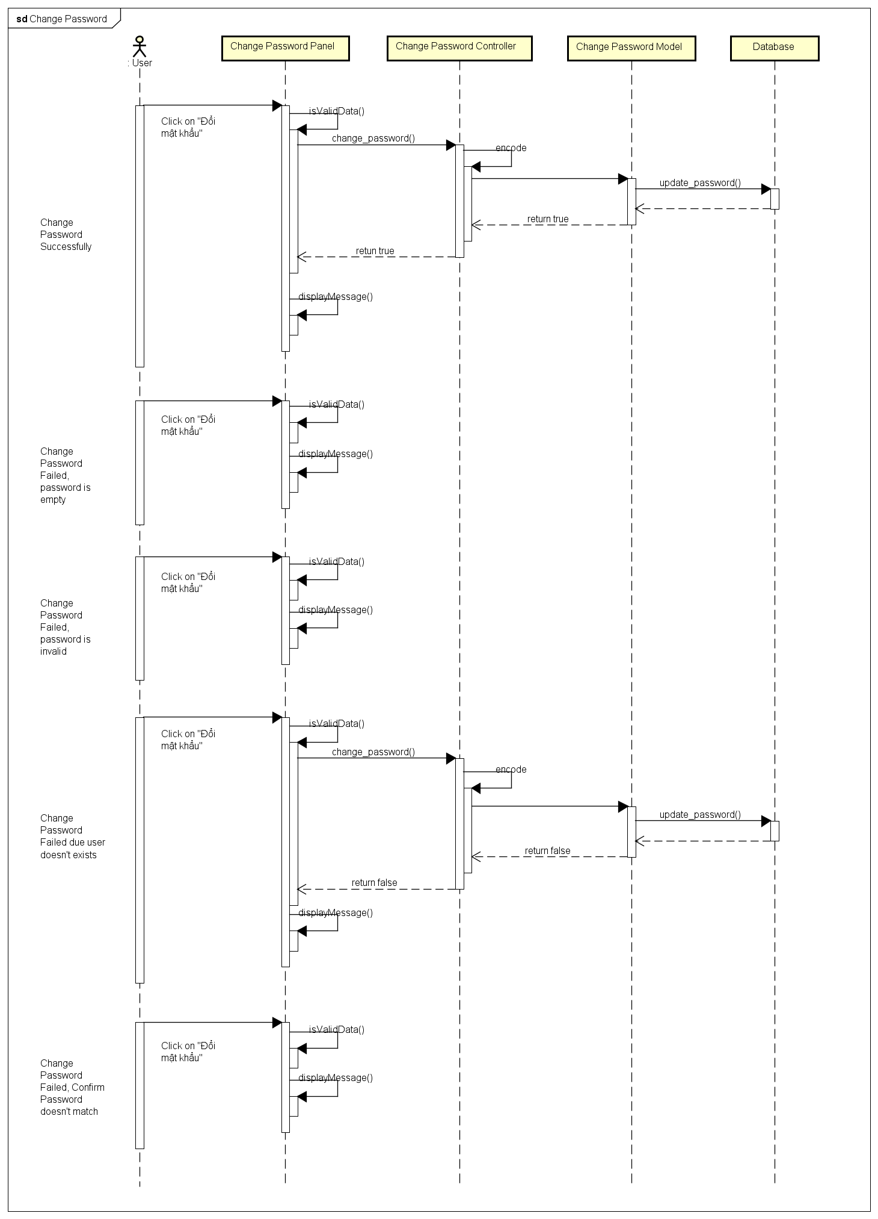

4.4.7. Forgot Password

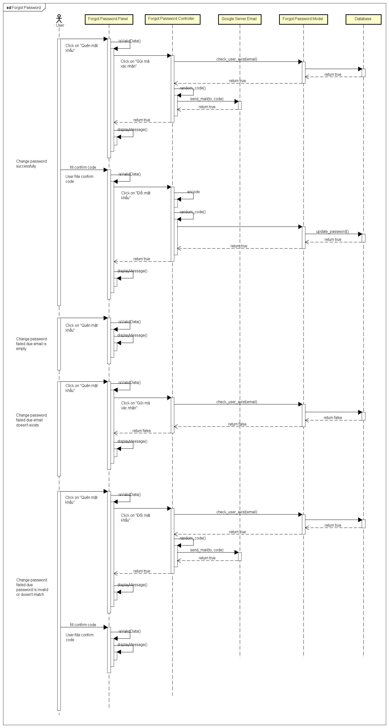

4.4.8. Edit Profile

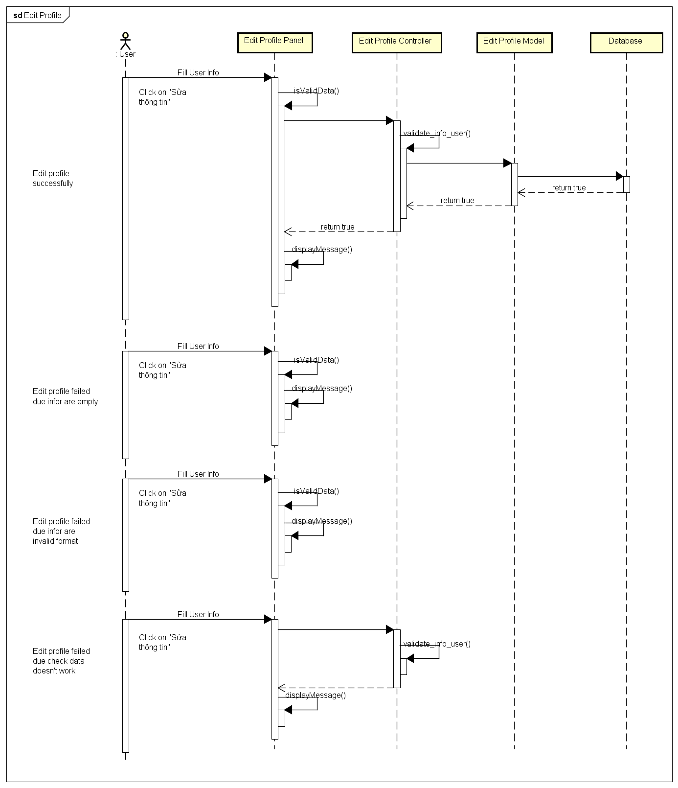

4.4.9. History

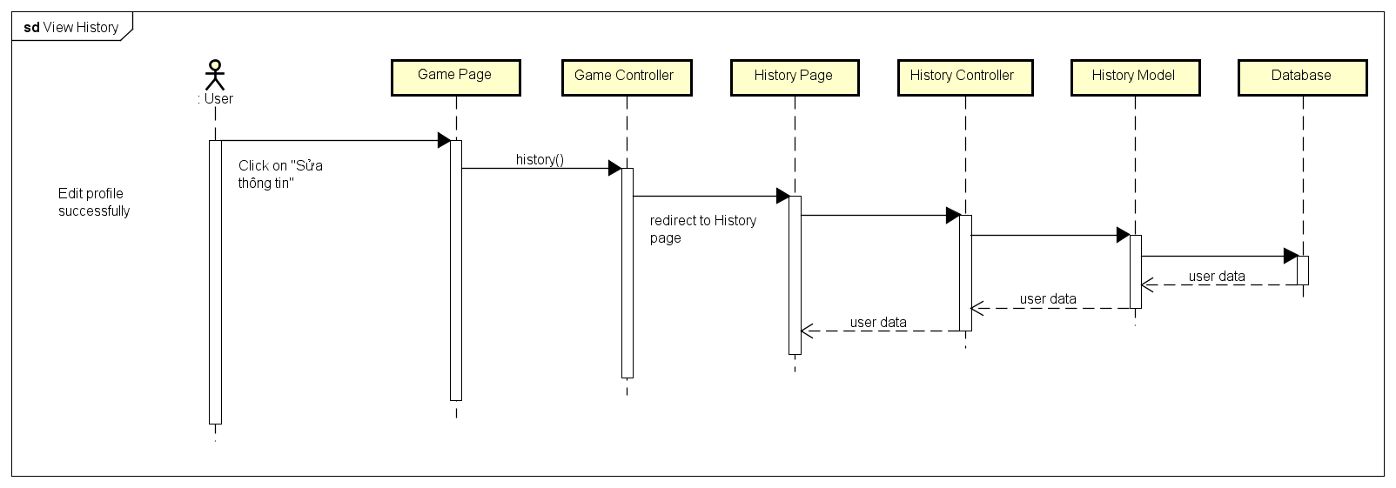

4.4.10. Notification

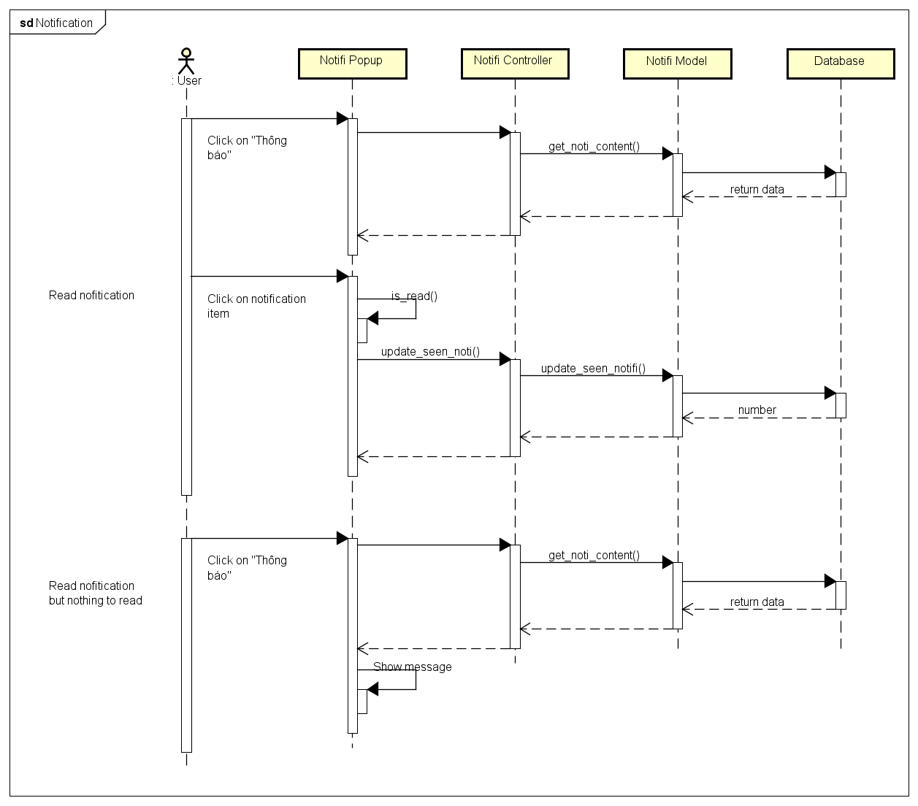

4.4.11. User Rankings

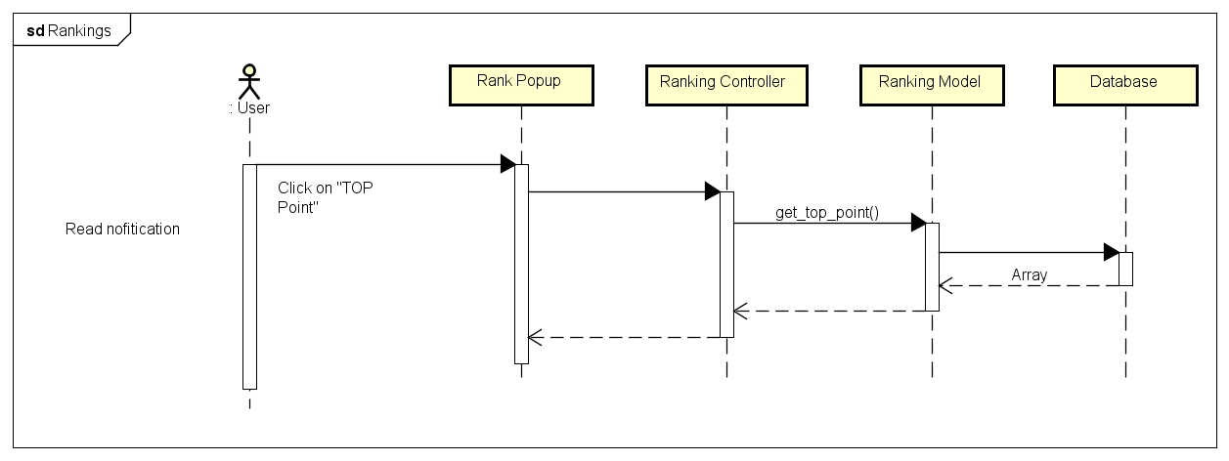

4.4.12. Create Challenges

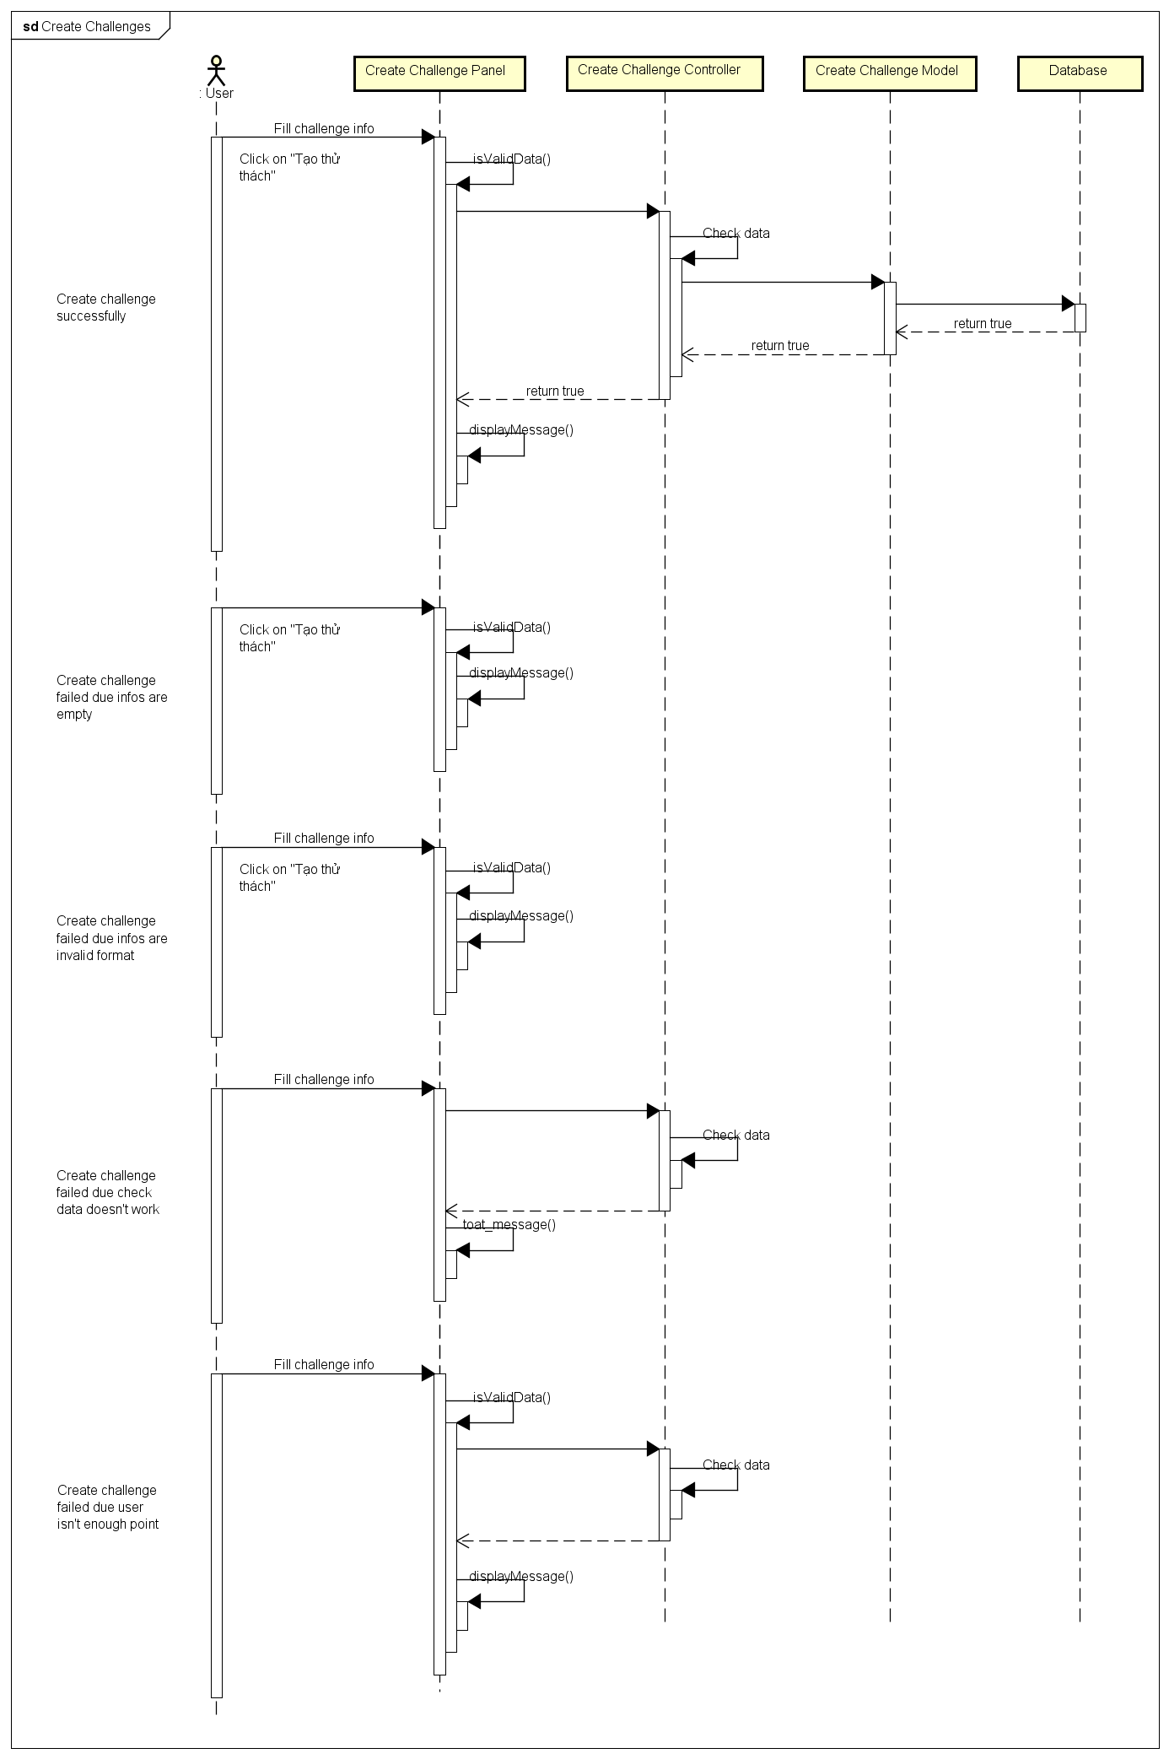

4.4.13. Bet On Traditional Game

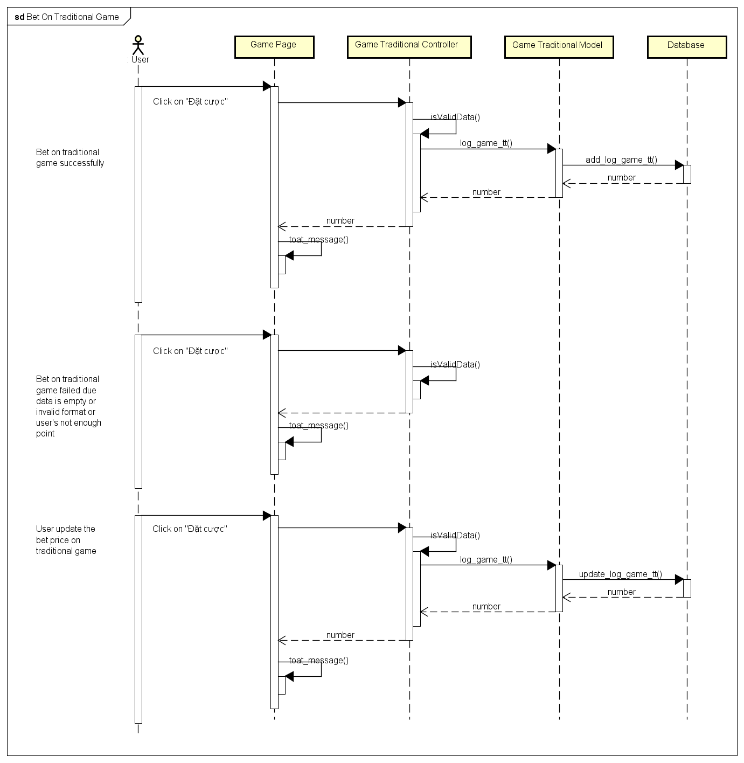

4.4.14. Bet On Challenge Game

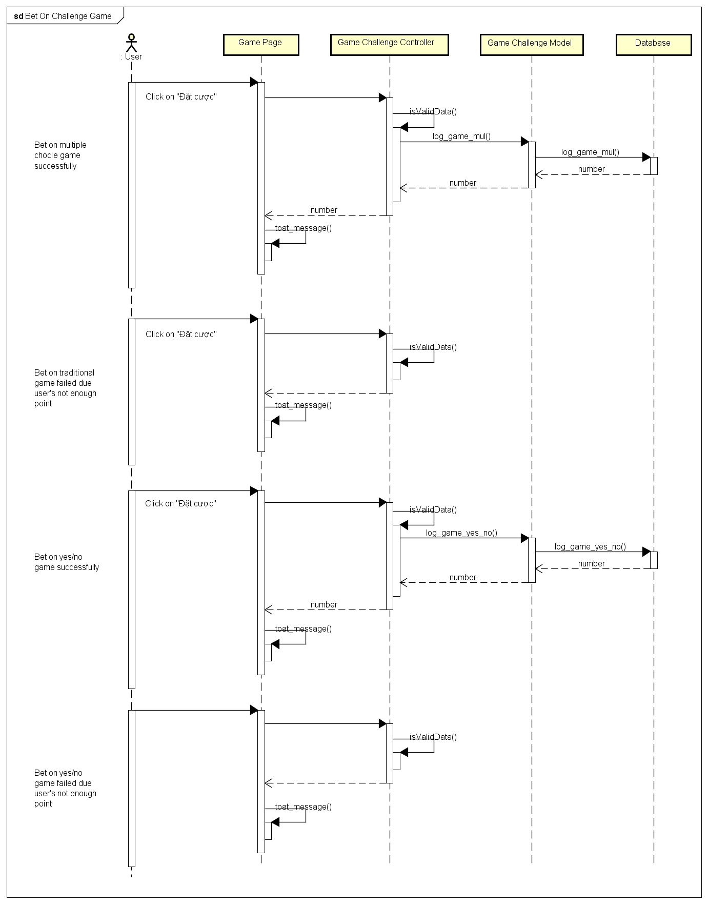

4.5. Activities Diagram

4.5.1. Register and Login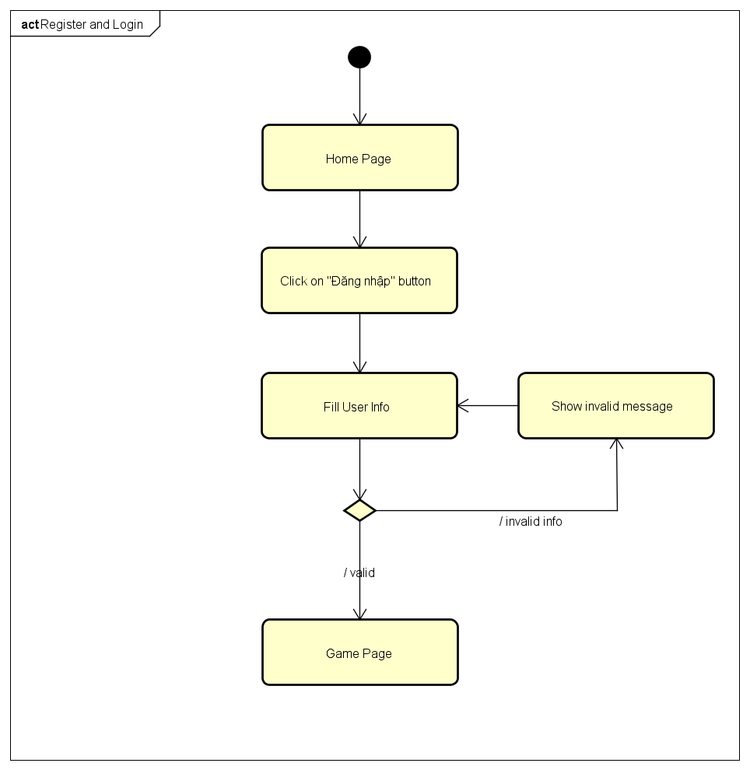

4.5.2. Login Using Facebook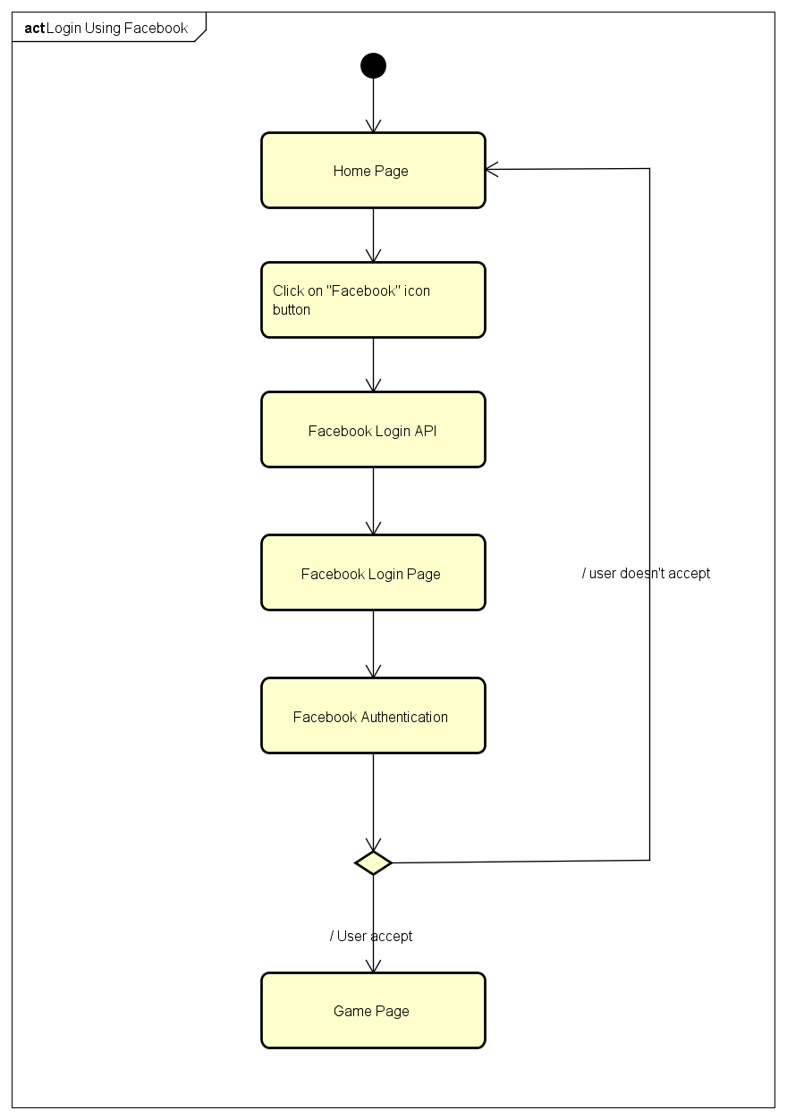

4.5.3. Login Using Google Plus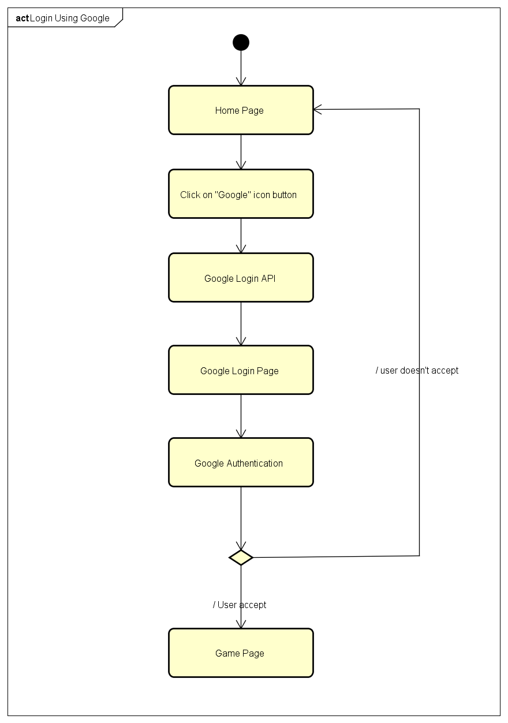

4.5.4. Logout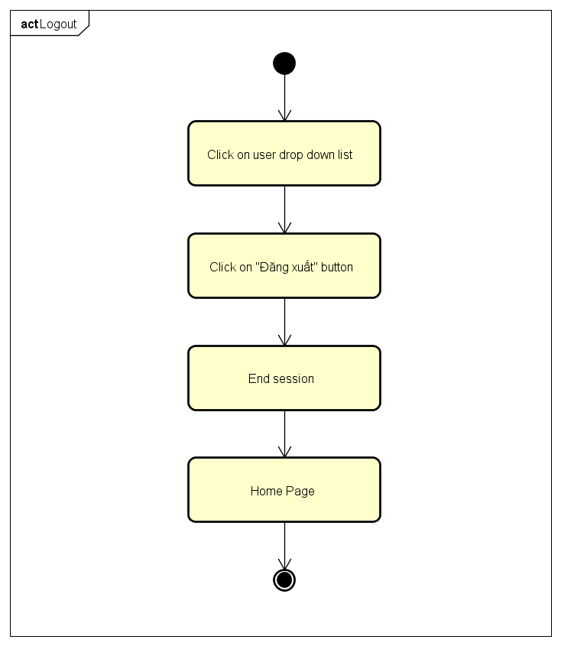

4.5.5. Change Password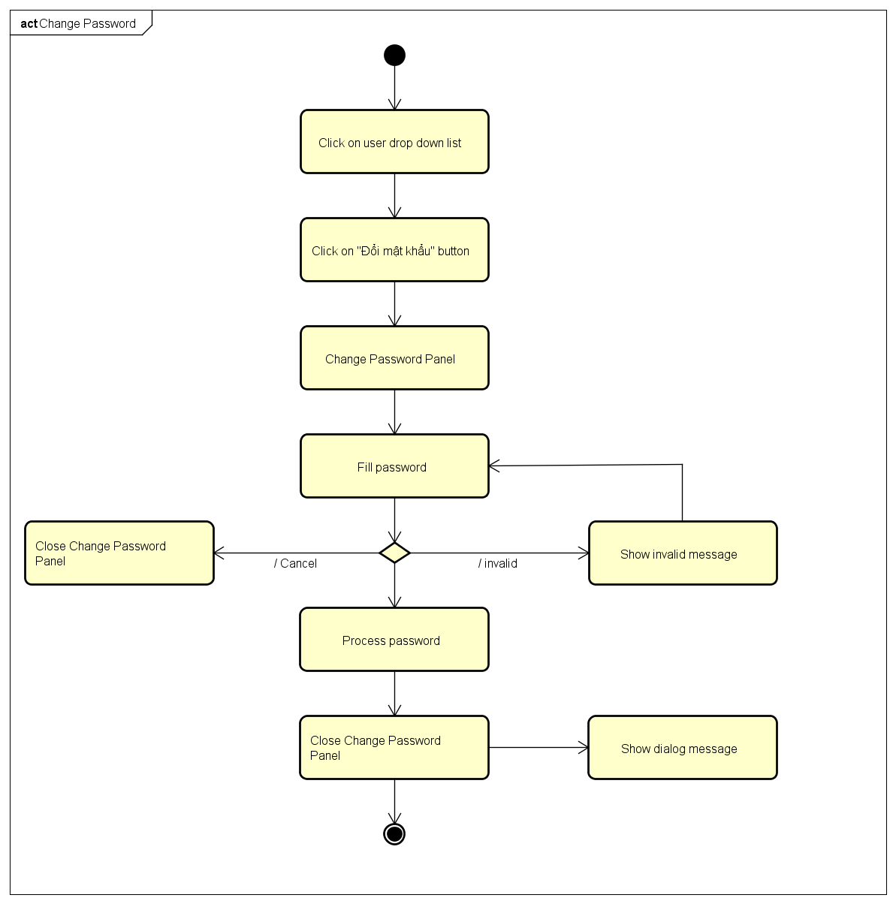

4.5.6. Forgot Password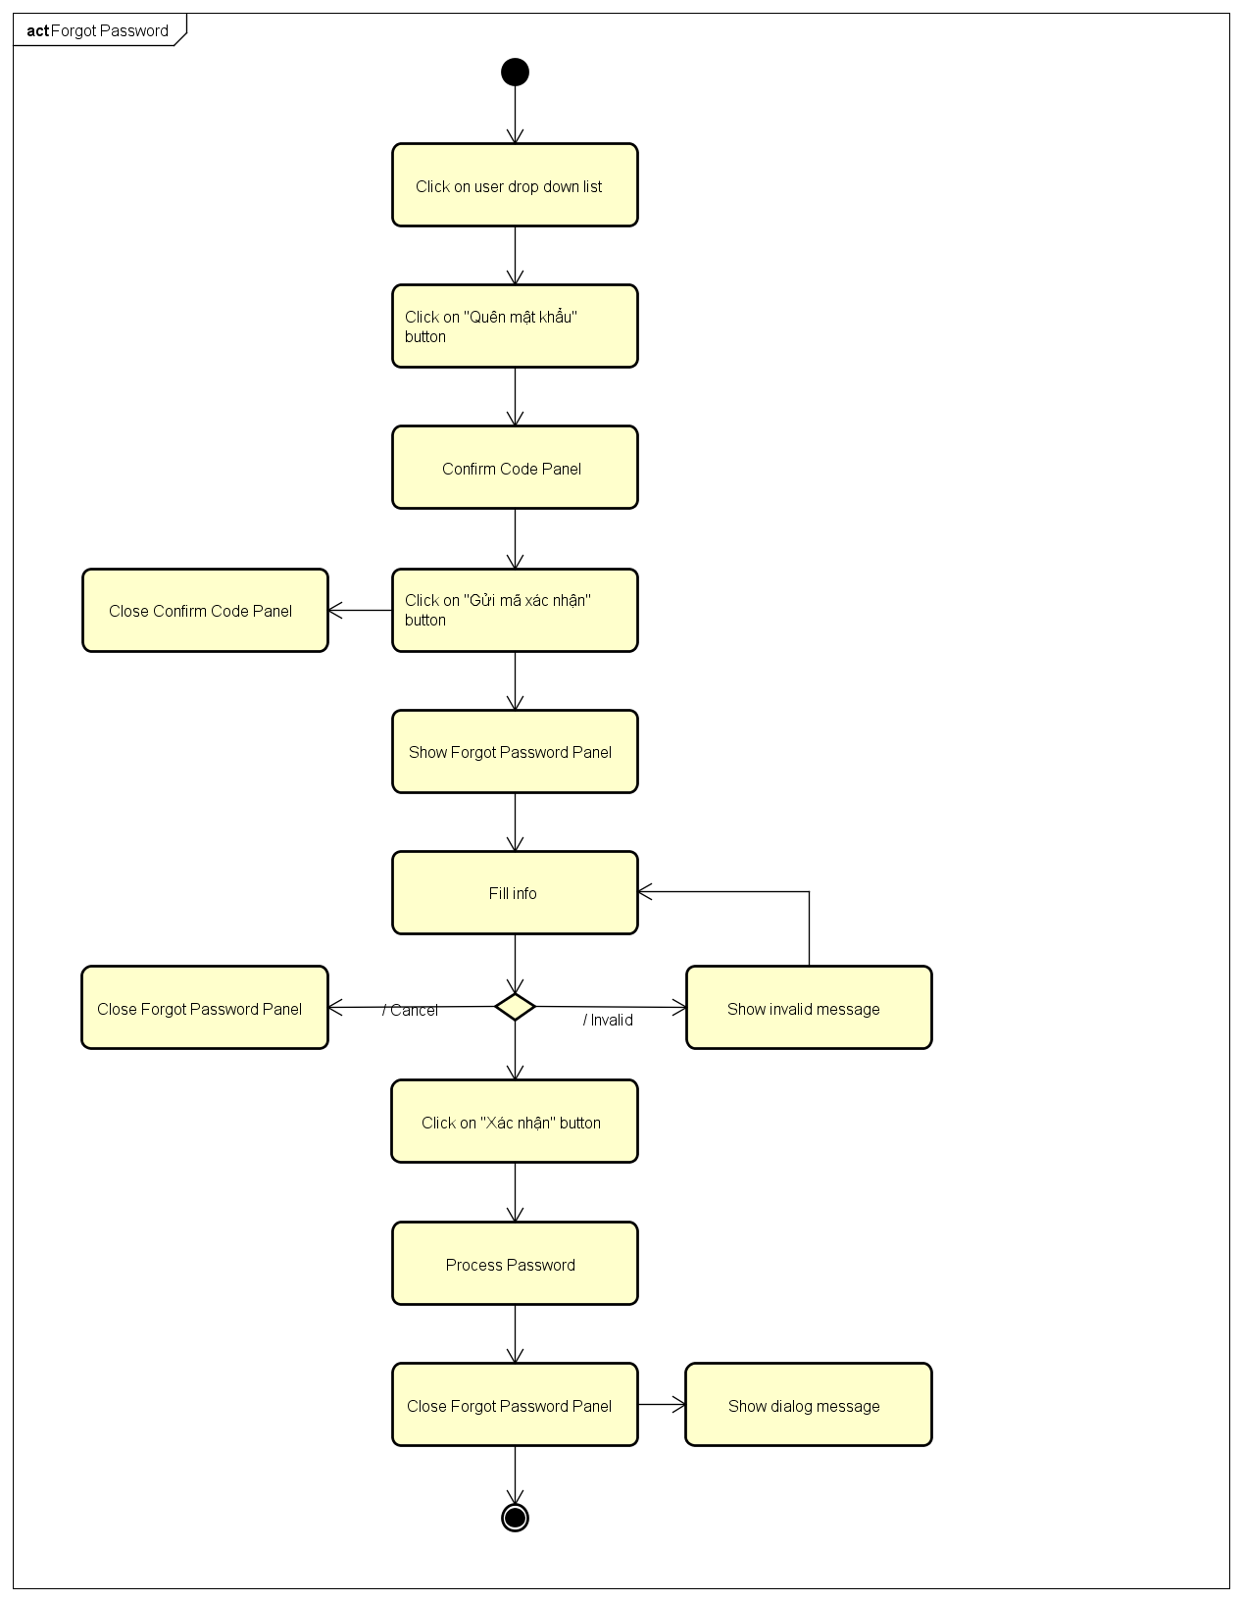

4.5.7. Edit Profile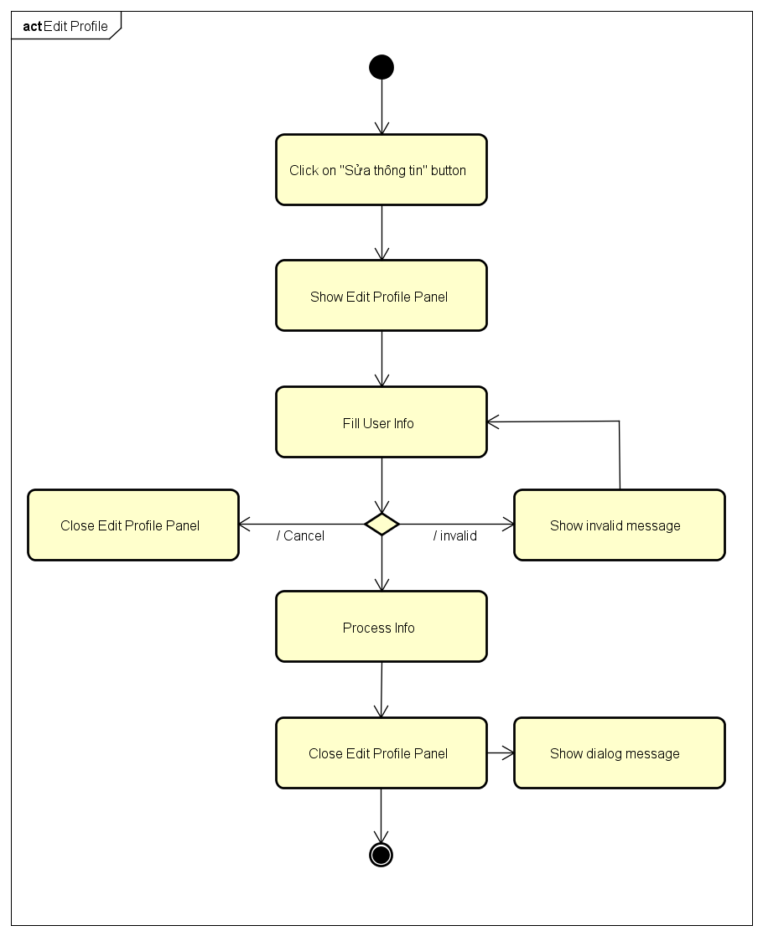

4.5.8. History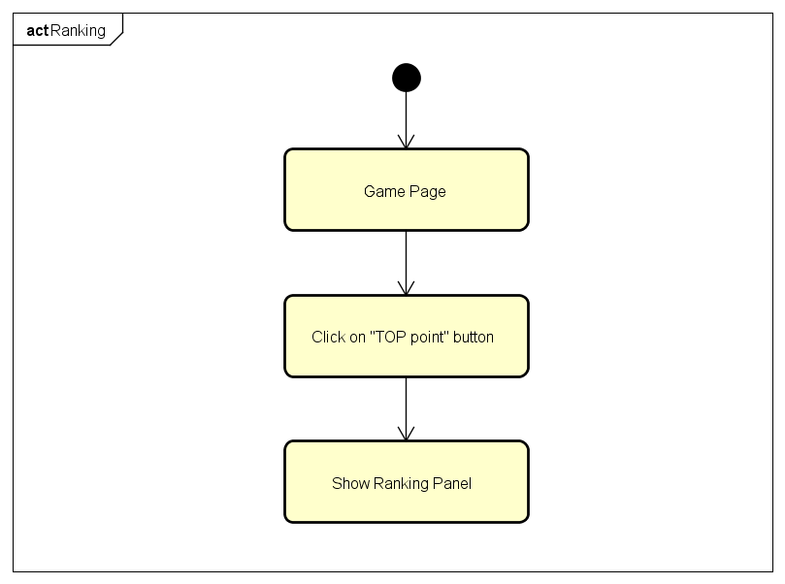

4.5.9. Notification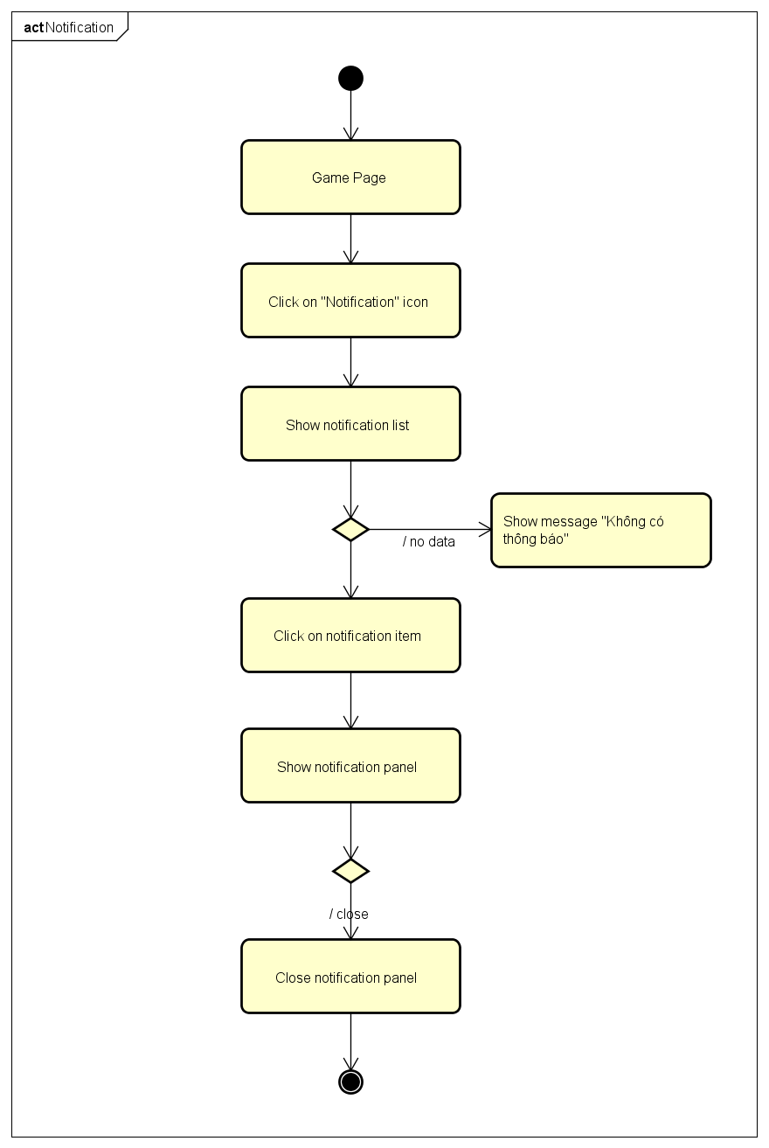

4.5.10. Ranking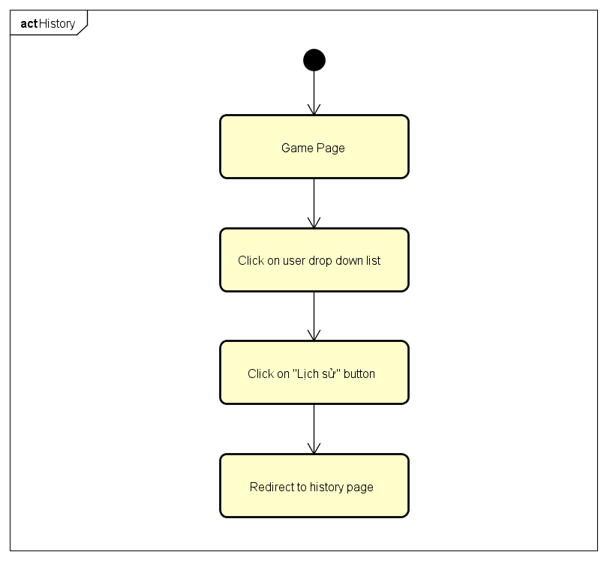

4.5.11. Create Challenges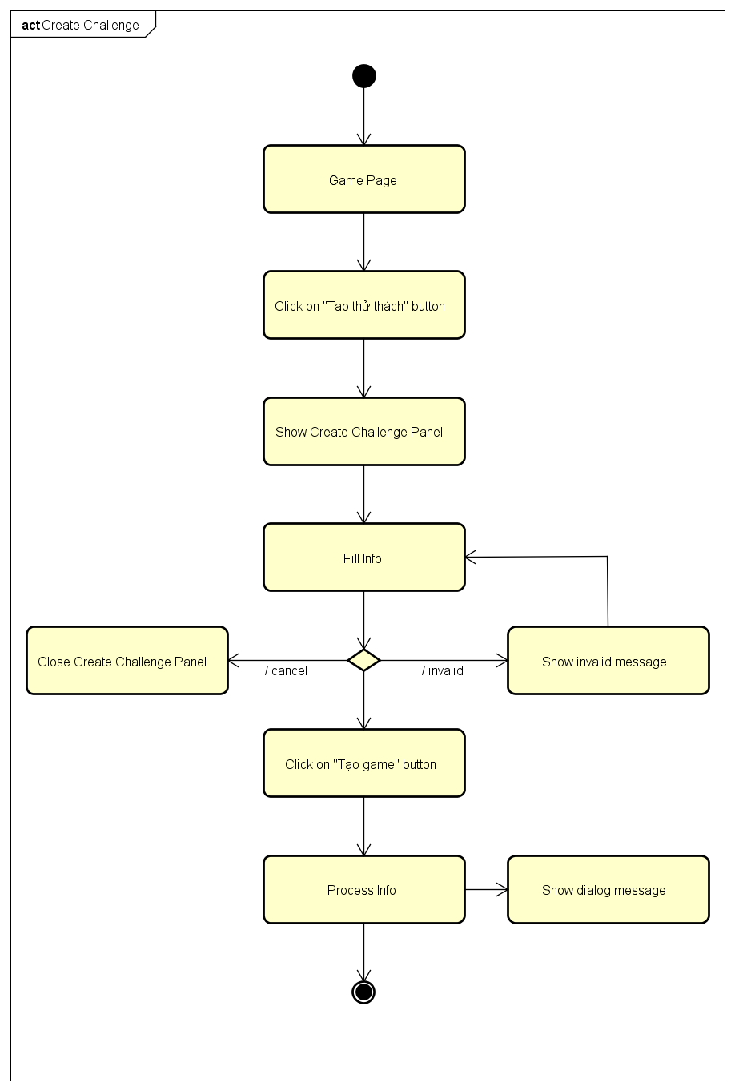

4.5.12. Bet On Traditional Game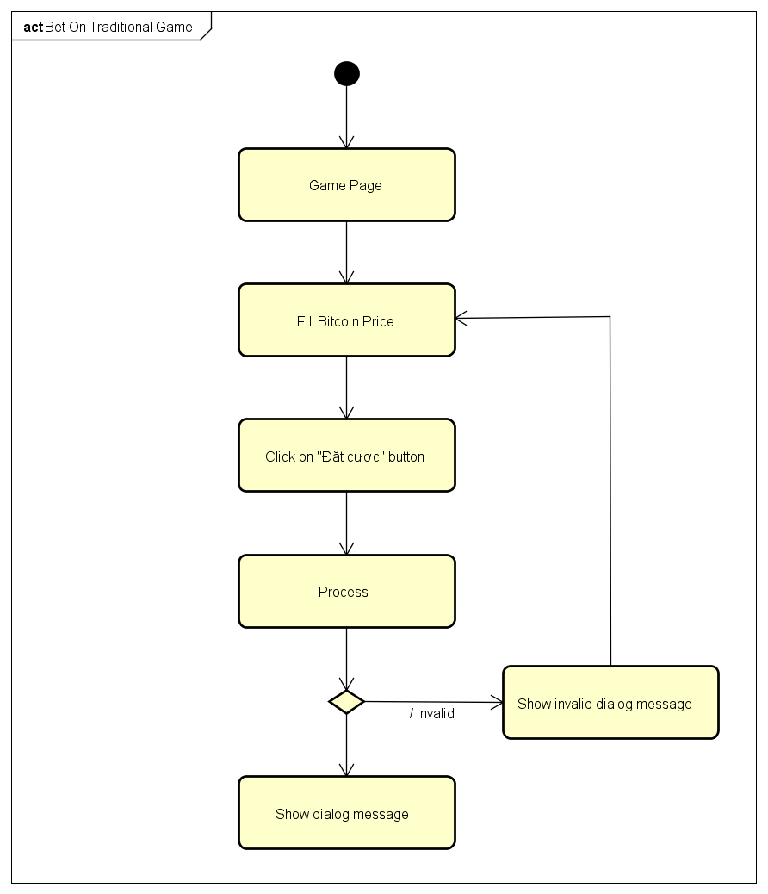

4.5.13. Bet On Challenge Game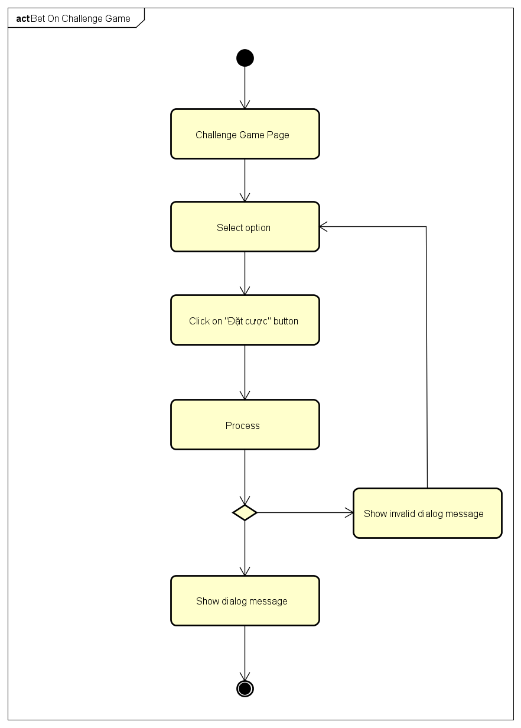

4.6. CRC Cards and Class Diagram

4.6.1. CRC Cards

4.6.2. Class Diagram

4.7. User Interface Design

4.7.1. Register and Login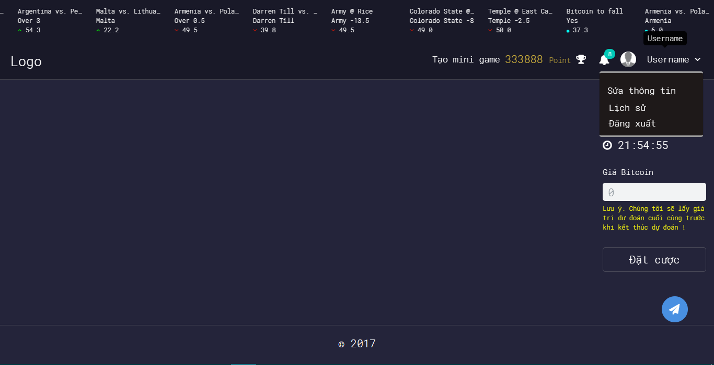

4.7.2. Login Using Facebook

4.7.3. Login Using Google Plus

4.7.4. Logout

4.7.5. Change Password

4.7.6. Forgot Password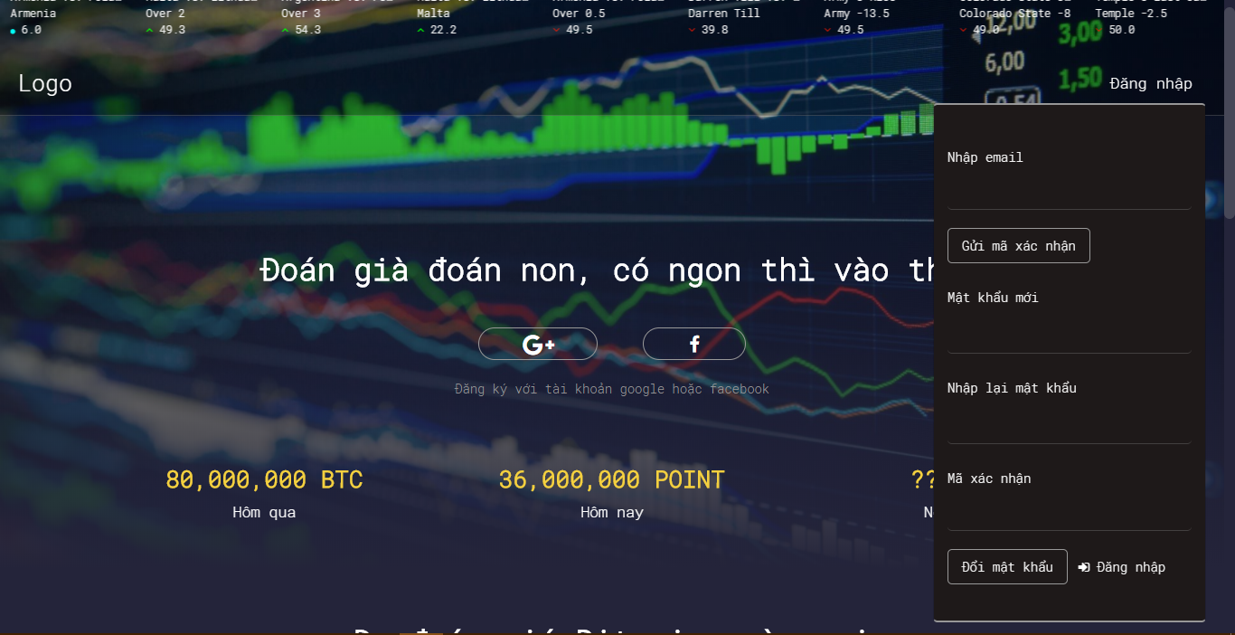

4.7.7. Edit Profile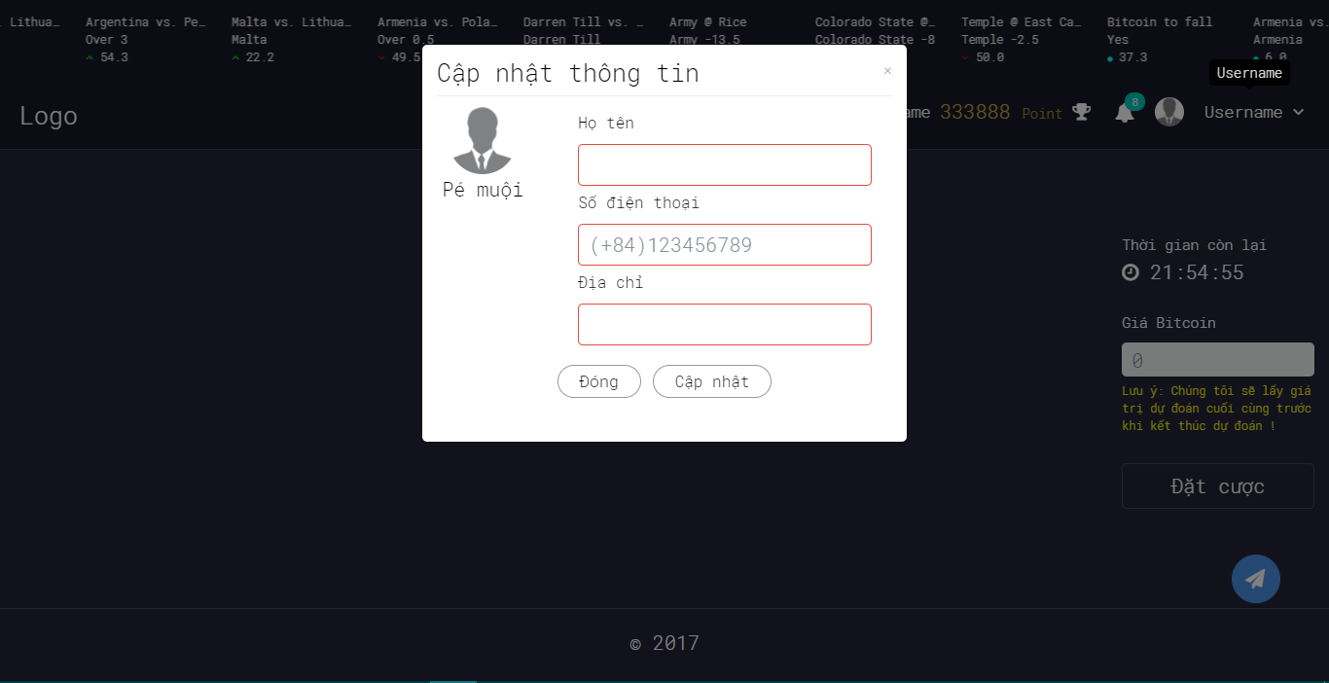

4.7.8. History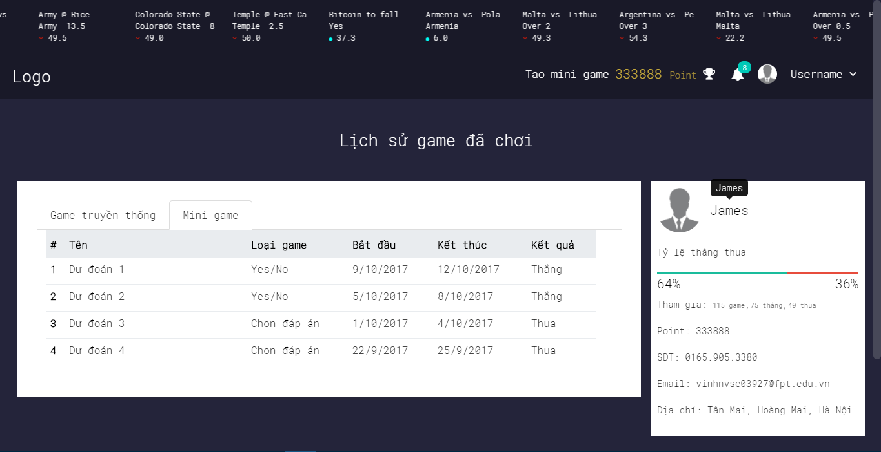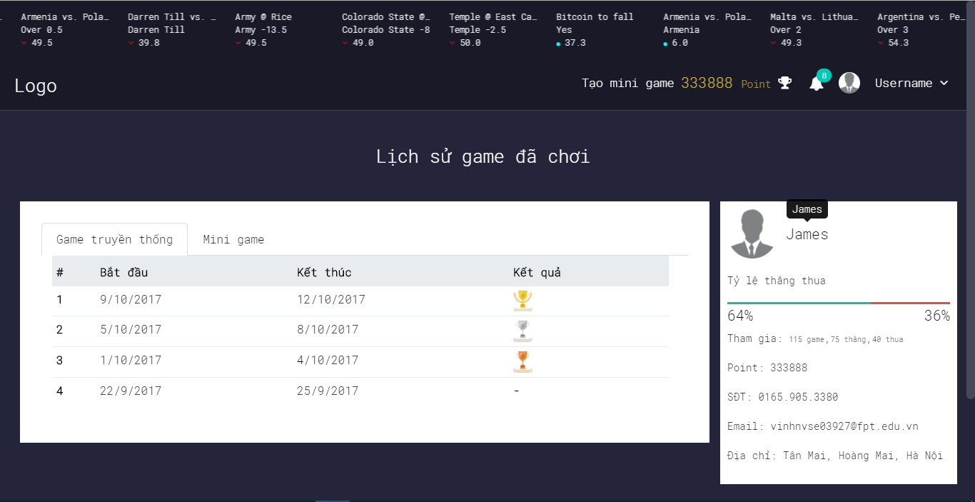

4.7.9. Notification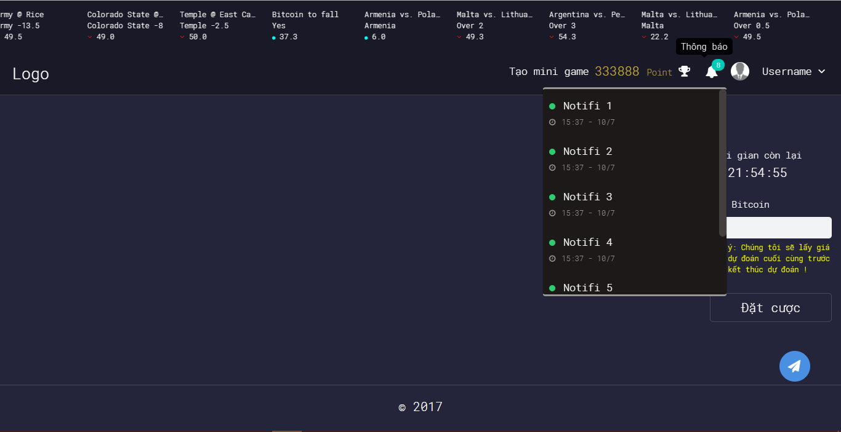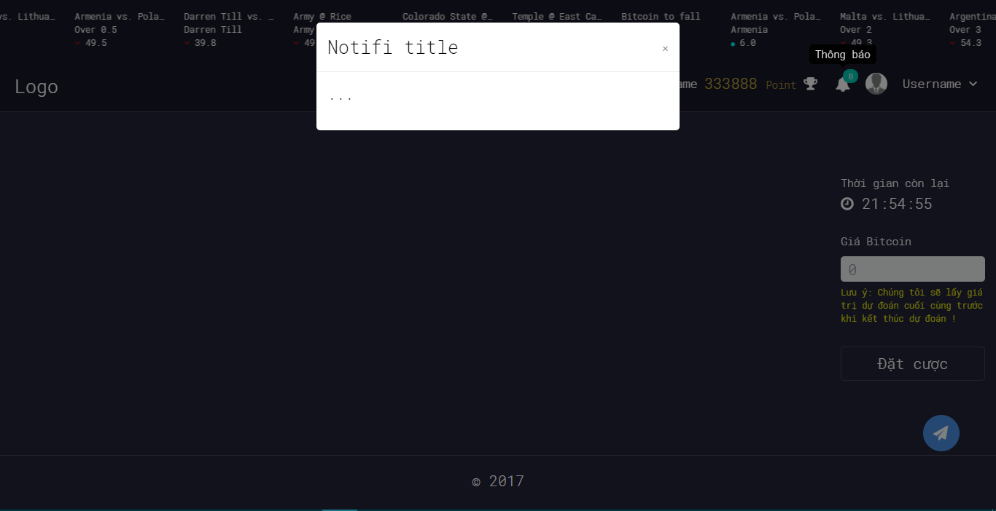

4.7.10. Ranking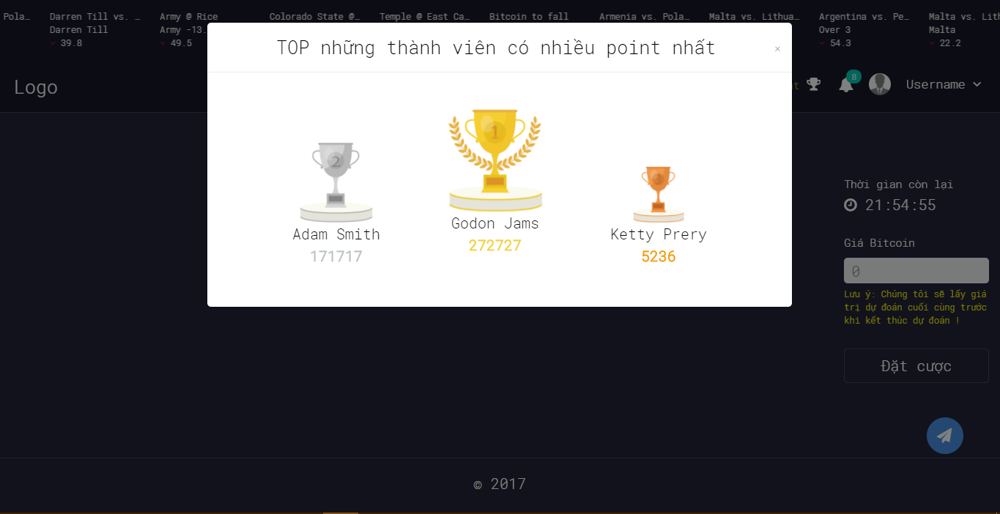

4.7.11. Create Yes/No Game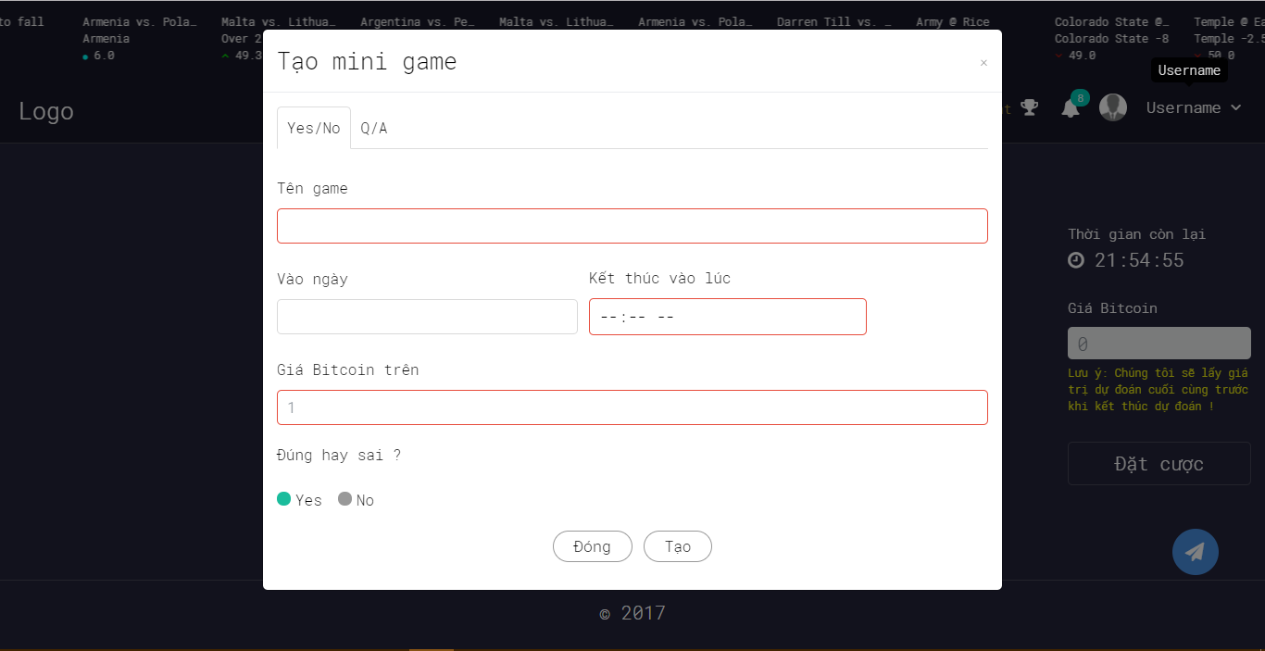

4.7.12. Create Multiple Choice Game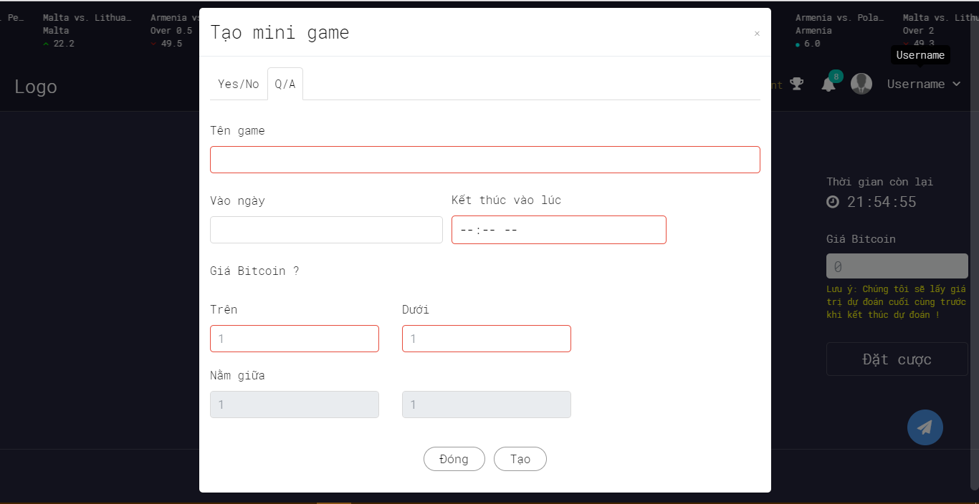

4.7.13. Bet On Traditional Game

4.7.14. Bet On Yes/No Game

4.7.15. Bet On Multiple Choice Game

4.7.16. YES/No Game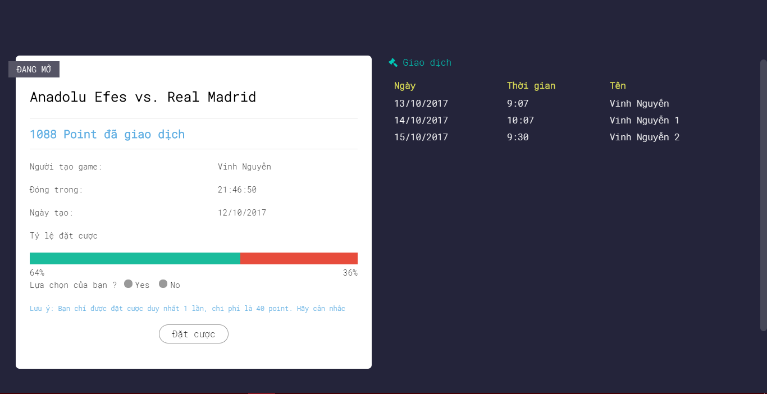

4.7.17. Multiple Choice Game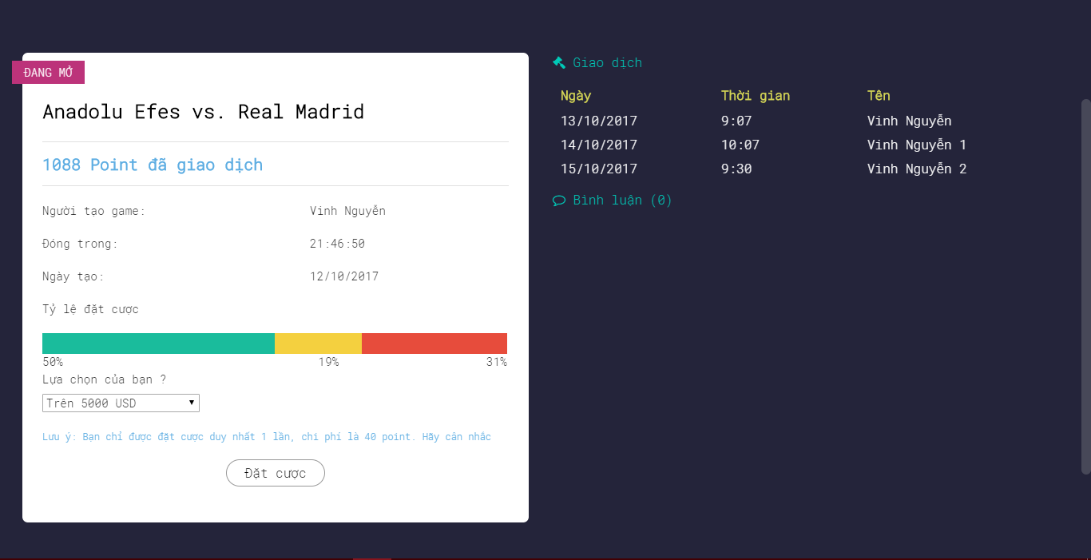

4.7. Database Design